


Operating Lease Support System Development
For


REPORT FRAMEWORK

Revision 1.0

Prepared by:

PT. Berlian Sistem Informasi

KTB Annex Bld. 4th Floor, Jl. Jend. A. Yani. Pulomas,
Tel. +62 21 4786 7575 (Hunting) Fax. +62 21 4714964 www.bsi.co.id

Document Control
Author | Setiyono
File Name | OS144028 - DSF OLSS - Report Framework Rev.1.0
Path | N/A
Create Date | 09/06/2015 14:22:00
Last Edited | 15/06/2015 11:22:00
Number of Pages | 19

Revision History
Date | Revision | Description | Author
09-June-2015 | 0.0 | Initial creation | Setiyono
15-June-2015 | 1.0 | Update distribution list and document approval | Setiyono

Distribution List
Name | Organization | Title
Mr. Ahmad Fikri | Dipo Star Finance, PT | DSF ITD Head
Mr. Deni Kusumah | Dipo Star Finance, PT | DSF ITD
Mr. Mukhlis Ibrahim | Dipo Star Finance, PT | DSF ITD
Mr. Delta Riangga | Dipo Star Finance, PT | DSF Project Manager
Mr. Feri Irawan | Berlian Sistem Informasi, PT | BSI Multifinance Division Head
Mr. Asra Haryadi | Berlian Sistem Informasi, PT | BSI Operation Unit Manager
Mr. Devilosa Indra Kamal | Berlian Sistem Informasi, PT | BSI Service Manager

Document Approval
By signing this document I acknowledge I have read the document and give the Project Management Team approval to proceed.
Role | Name | Signature | Date
DSF ITD Head | Mr. Ahmad Fikri
DSF ITD | Mr. Deni Kusumah
DSF ITD | Mr. Mukhlis Ibrahim
BSI Operation Unit Manager | Mr. Asra Haryadi
BSI Service Manager | Mr. Devilosa Indra Kamal

Table of Contents
Document Control 2
Revision History 2
Distribution List 2
Document Approval 2
Bab 1. Regulation of Making Report 4
1.1 Introduction 4
1.2 Prerequisite 4
1.3 Instruction 4
Bab 2. Regulation of Using Report 15
2.1 Introduction 15
2.2 Prerequisite 15
2.3 Instruction 15

Bab 1. Regulation of Making Report
  - Introduction
Required a standard in making report on the OLSS application.
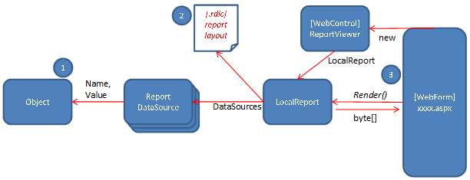
Figure 1. Flow of making report
  - Prerequisite
Requirements that must be met to make a report:
- Ms Windows 7 or later
- Ms Visual Studio 2013 or later
- Ms SQL Server 2012 or later
- .Net Framework 4.5 or later
  - Instruction
This section will explain step by step how to create RDLC report in Visual Studio 2013 (Developer side):
- Adding the Object class
We will make use of Object class to populate the RDLC report with data from database. Our first step would be to add an Object class. Right-click on selected Project then select Add New Item then select Class.
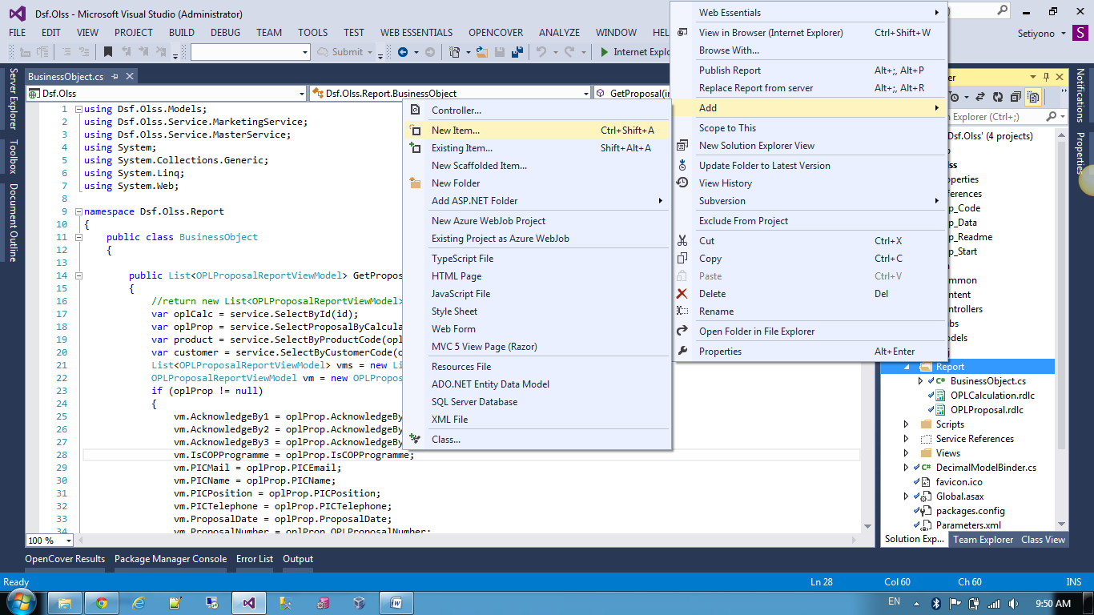
Figure 2. Add New Item

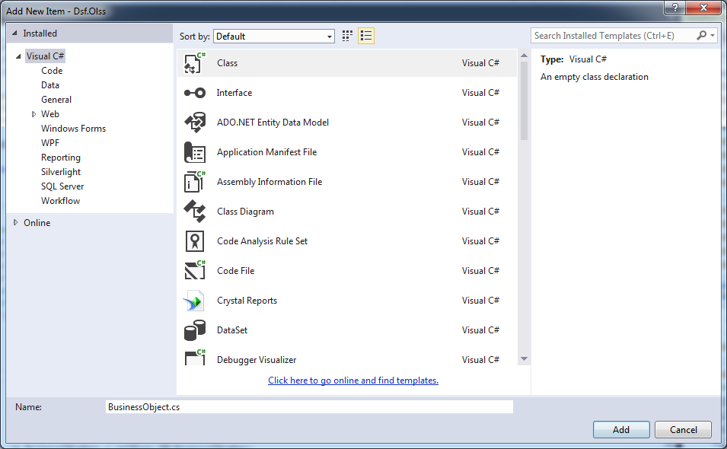
Figure 3. Create New Class

Then add the following code to define the data that will appear in the report
using Dsf.Olss.Models;
using Dsf.Olss.Service.MarketingService;
using Dsf.Olss.Service.MasterService;
using System;
using System.Collections.Generic;
using System.Linq;
using System.Web;

namespace Dsf.Olss.Report
{
public class BusinessObject
{
public List<OPLProposalReportViewModel> GetProposal(int id, IOPLCalculationService service)
{
var oplCalc = service.SelectById(id);
var oplProp = service.SelectProposalByCalculationNumber(oplCalc.OPLCalculationNumber);
var product = service.SelectByProductCode(oplCalc.ProductCode);
var customer = service.SelectByCustomerCode(oplCalc.CustomerCode);
List<OPLProposalReportViewModel> vms = new List<OPLProposalReportViewModel>();
OPLProposalReportViewModel vm = new OPLProposalReportViewModel();
if (oplProp != null)
{
vm.AcknowledgeBy1 = oplProp.AcknowledgeBy1;
vm.AcknowledgeBy2 = oplProp.AcknowledgeBy2;
vm.AcknowledgeBy3 = oplProp.AcknowledgeBy3;
vm.IsCOPProgramme = oplProp.IsCOPProgramme;
vm.PICMail = oplProp.PICEmail;
vm.PICName = oplProp.PICName;
vm.PICPosition = oplProp.PICPosition;
vm.PICTelephone = oplProp.PICTelephone;
vm.ProposalDate = oplProp.ProposalDate;
vm.ProposalNumber = oplProp.OPLProposalNumber;
vm.Remarks = oplProp.Remarks;
vm.ProposeBy = oplProp.ProposeBy;
vm.PurposeOfUse = oplProp.PurposeOfUse;
vm.To = oplProp.To;
vm.ApproveBy = oplProp.ApproveBy;
vm.DeadlineQuotationSubmission = oplProp.Validuntil;
}
vm.Address = customer.Address;
vm.BrandName = product.BrandName;
vm.BusinessEconomySector = customer.BusinessEconomySector;
vm.CustomerName = customer.CustomerName;
vm.CustomerTelephone = customer.Telephone;
vm.LeasePeriodPlan = oplCalc.LeasePeriodPlan;
vm.MaintenanceType = service.GetOptionValueName(System.Convert.ToInt32(oplCalc.MaintenanceType));
vm.ModelName = product.ModelName;
vm.MonthlyInstallmentAmount = oplCalc.MonthlyInstallmentAmount;
vm.OPLCalculationNumber = oplCalc.OPLCalculationNumber;
vm.ProductPrice = oplCalc.ProductPrice;
vm.Ratio = oplCalc.MonthlyInstallmentSetting;
if (oplCalc.OPLBasicCondition != null)
{
vm.ResidualValueAmount = oplCalc.OPLBasicCondition.ResidualValueAmount;
vm.SResidualValueAmount = oplCalc.OPLBasicCondition.SResidualValueAmount;
}
vm.TotalProfitAmount = oplCalc.TotalProfitAmount;
vm.TotalUnitQuantity = oplCalc.TotalUnitQuantityLease;
vms.Add(vm);
return vms;
}

public List<OPLProposalAttachmentReportViewModel> GetOPLCalculation(int id, IOPLCalculationService service)
{
List<OPLProposalAttachmentReportViewModel> vms = new List<OPLProposalAttachmentReportViewModel>();
var oplCalc = service.SelectById(id);
service.Calculate(ref oplCalc);
var product = service.SelectByProductCode(oplCalc.ProductCode);
var customer = service.SelectByCustomerCode(oplCalc.CustomerCode);
var oplProp = service.SelectProposalByCalculationNumber(oplCalc.OPLCalculationNumber);
OPLProposalAttachmentReportViewModel vm = new OPLProposalAttachmentReportViewModel();
if (oplProp != null)
{
vm.IsCOPProgramme = oplProp.IsCOPProgramme;
}
if (oplCalc.OPLBasicCondition != null)
{
vm.AccesoriesDiscount = oplCalc.OPLBasicCondition.AccesoriesDiscount;
vm.AccesoriesPrice = oplCalc.OPLBasicCondition.AccesoriesPrice;
vm.AccesoriesPriceTotal = oplCalc.OPLBasicCondition.AccesoriesPriceTotal;
vm.ATPMDiscount = oplCalc.OPLBasicCondition.ATPMDiscount;
vm.CarroserrieDiscount = oplCalc.OPLBasicCondition.CarroserrieDiscount;
vm.CarroserriePrice = oplCalc.OPLBasicCondition.CarroserriePrice;
vm.CarroserriePriceTotal = oplCalc.OPLBasicCondition.CarroserriePriceTotal;
vm.ProductDiscount = oplCalc.OPLBasicCondition.ProductDiscount;
vm.ProductPrice = oplCalc.OPLBasicCondition.ProductPrice;
vm.ProductPriceTotal = oplCalc.OPLBasicCondition.ProductPriceTotal;
vm.SResidualValue = oplCalc.OPLBasicCondition.SResidualValueAmount;
vm.ResidualValue = oplCalc.OPLBasicCondition.ResidualValueAmount;
}
if (oplCalc.OPLFinanceCondition != null)
{
vm.AdministrationFee = oplCalc.OPLFinanceCondition.AdministrationFeeAmount;
vm.BorrowingEffective = oplCalc.OPLFinanceCondition.BorrowingEffectivePercent;
vm.DemobilizationAmount = oplCalc.OPLFinanceCondition.DemobilizationFeeAmount;
vm.DPBeforeBASTAccesories = oplCalc.OPLFinanceCondition.DPBeforeBASTAccesories;
vm.DPBeforeBASTCarroserie = oplCalc.OPLFinanceCondition.DPBeforeBASTCarroserie;
vm.DPBeforeBASTProduct = oplCalc.OPLFinanceCondition.DPBeforeBASTProduct;
vm.DPPeriodBASTAccesories = oplCalc.OPLFinanceCondition.DPPeriodBASTAccesories;
vm.DPPeriodBASTCarroserie = oplCalc.OPLFinanceCondition.DPPeriodBASTCarroserie;
vm.DPPeriodBASTProduct = oplCalc.OPLFinanceCondition.DPPeriodBASTProduct;
vm.MobilizationAmount = oplCalc.OPLFinanceCondition.MobilizationFeeAmount;
vm.PrimeEffective = oplCalc.OPLFinanceCondition.PrimeEffectivePercent;
vm.PSBeforeBASTAccesories = oplCalc.OPLFinanceCondition.PSBeforeBASTAccesories;
vm.PSBeforeBASTCarroserie = oplCalc.OPLFinanceCondition.PSBeforeBASTCarroserie;
vm.PSBeforeBASTProduct = oplCalc.OPLFinanceCondition.PSBeforeBASTProduct;
vm.PSPeriodBASTAccesories = oplCalc.OPLFinanceCondition.PSPeriodBASTAccesories;
vm.PSPeriodBASTCarroserie = oplCalc.OPLFinanceCondition.PSPeriodBASTCarroserie;
vm.PSPeriodBASTProduct = oplCalc.OPLFinanceCondition.PSPeriodBASTProduct;
vm.ReplacementCarAmount = oplCalc.OPLFinanceCondition.ReplacementCarAmount;
vm.SpreadEffective = oplCalc.OPLFinanceCondition.SpreadEffectivePercent;
vm.TermOfPayment = oplCalc.OPLFinanceCondition.TermPaymentDays;
vm.KEURREneewalFee = oplCalc.OPLFinanceCondition.KIRRenewaFee.HasValue ? (oplCalc.OPLFinanceCondition.KIRRenewaFee.Value * oplCalc.PeriodInYears) : 0;
vm.STNKReneewalFee = oplCalc.OPLFinanceCondition.STNKRenewalFee.HasValue ? (oplCalc.OPLFinanceCondition.STNKRenewalFee.Value * oplCalc.PeriodInYears) : 0;
vm.RegistrationValueAmount = oplCalc.OPLFinanceCondition.RegistrationValueAmount.HasValue ? oplCalc.OPLFinanceCondition.RegistrationValueAmount.Value : 0;
vm.RegistrationValueRate = oplCalc.OPLFinanceCondition.RegistrationValueRate.HasValue ? oplCalc.OPLFinanceCondition.RegistrationValueRate.Value : 0;
}
if (oplCalc.OPLInsuranceCondition != null)
{
vm.InsuranceIncome = oplCalc.OPLInsuranceCondition.ComissionAmount;
vm.MediatorFeeAmount = oplCalc.OPLInsuranceCondition.ComissionAmount;
vm.NetPremium = oplCalc.OPLInsuranceCondition.NetPremium;
vm.TotalGrossPremium = oplCalc.OPLInsuranceCondition.TotalGrossPremium;
vm.CommissionAmount = oplCalc.OPLInsuranceCondition.ComissionAmount;
}
if (oplCalc.OPLMaintenanceCondition != null)
{
vm.TotalMaintenanceAmount = oplCalc.OPLMaintenanceCondition.TotalMaintenanceAmount;
}
var maintenanceTypeNames = service.GetOptionValueName(System.Convert.ToInt32(oplCalc.MaintenanceType));
vm.AccesoriesType = oplCalc.AccessoriesType;
vm.BrandName = product.BrandName;
vm.CarroserrieType = oplCalc.CarroserrieType;
vm.InsuranceCost = oplCalc.InsuranceCost;
vm.OPLCalculationNumber = oplCalc.OPLCalculationNumber;
vm.InterestExpense = oplCalc.InterestExpense;
vm.InterestExpenseBAST = oplCalc.InterestExpenseBAST;
vm.InterestExpenseTOP = oplCalc.InterestCostTop;
vm.LeasePeriodPlan = oplCalc.LeasePeriodPlan;
vm.MaintenanceCost = oplCalc.MaintenanceCost;
vm.MaintenanceType = maintenanceTypeNames;
vm.ModelName = product.ModelName;
vm.MonthlyInstallmentAmount = oplCalc.MonthlyInstallmentAmount;
vm.MonthlyInstallmentSetting = oplCalc.MonthlyInstallmentSetting;
vm.ReplacementUnitCost = oplCalc.ReplacementUnitCost;
vm.TotalCost = oplCalc.TotalCost;
vm.TotalPrice = oplCalc.ProductPrice;
vm.TotalIncome = oplCalc.TotalProfitAmount.HasValue ? oplCalc.TotalProfitAmount.Value : 0;
vm.TotalMonthlyInstallmentAmount = oplCalc.MonthlyInstallmentAmount * oplCalc.LeasePeriodPlan;
vm.TotalProfit = oplCalc.TotalProfitAmount;
vms.Add(vm);
return vms;
}
}
}
Figure 4. The BusinessObject class code

- Adding the RDLC Report
Using the Add New Item option in Visual Studio to add new RDLC report. Select Report item and provide name.
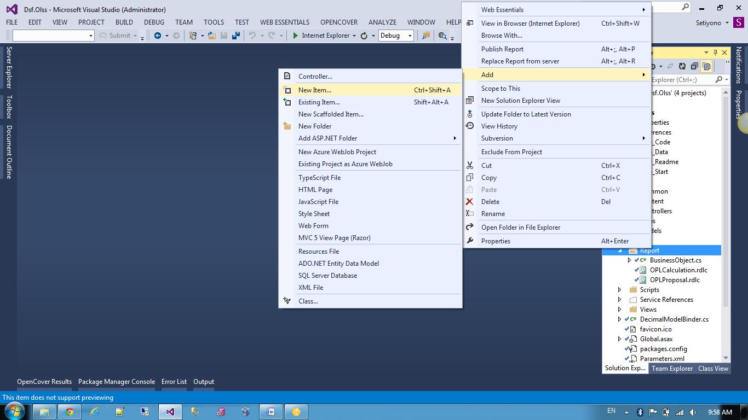
Figure 5. Add New Item

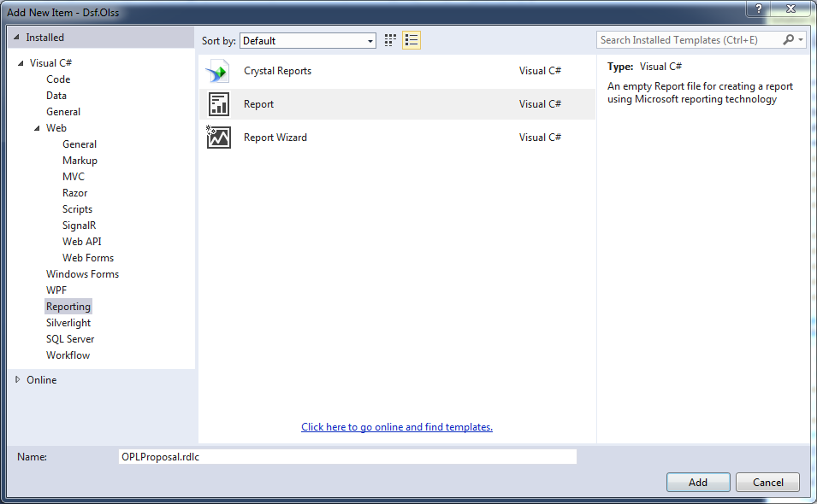
Figure 6. Create New RDLC Report

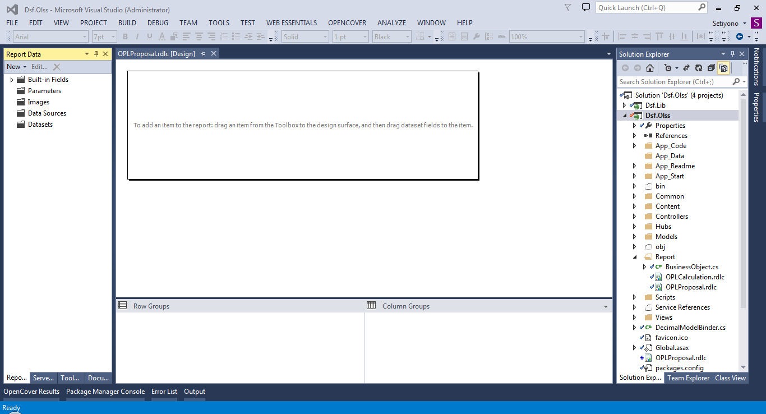
Figure 7. View of RDLC Report

- Choose the DataSource
Now We need to choose the DataSource for the RDLC Report. Thus We need to select the Object class that We have created earlier.
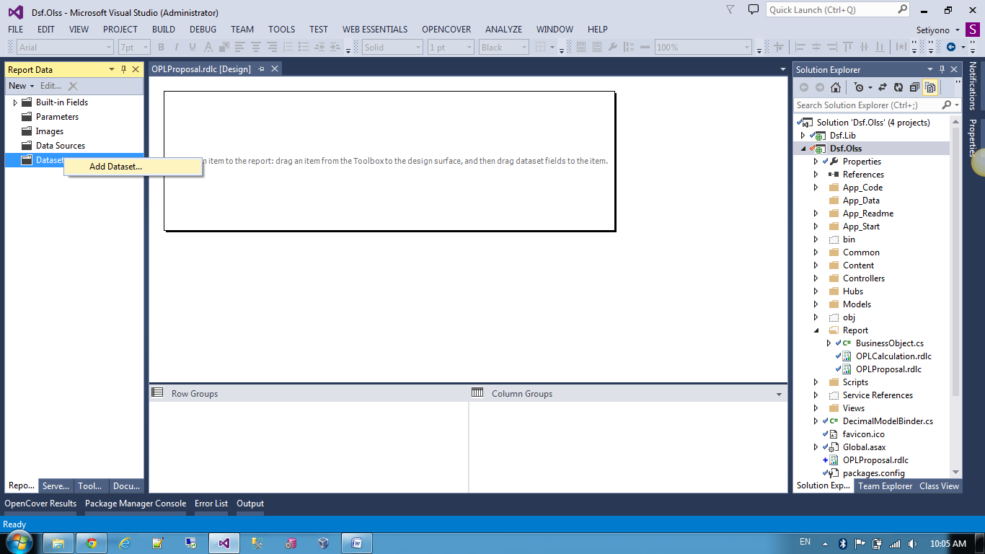
Figure 8. Right-click, then click Add Dataset

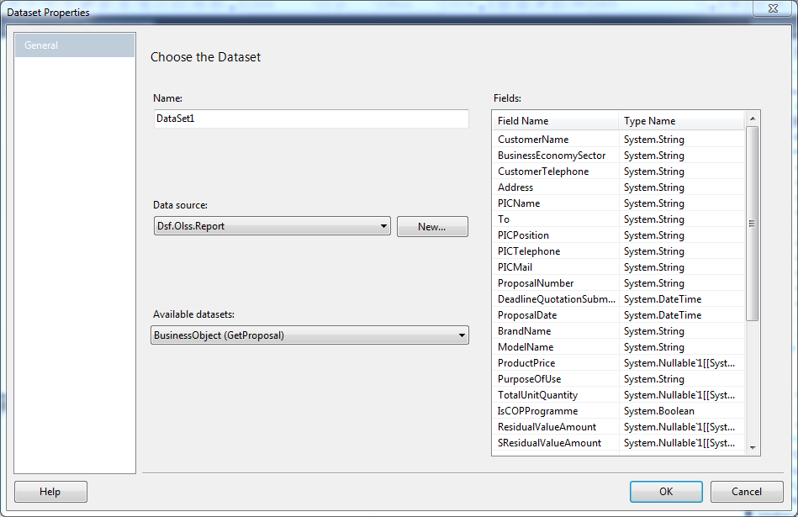
Figure 9. Determine Datasource

- Designing Report
Next We need to design reports follow the example given. Use control on toolbox for designing reports.
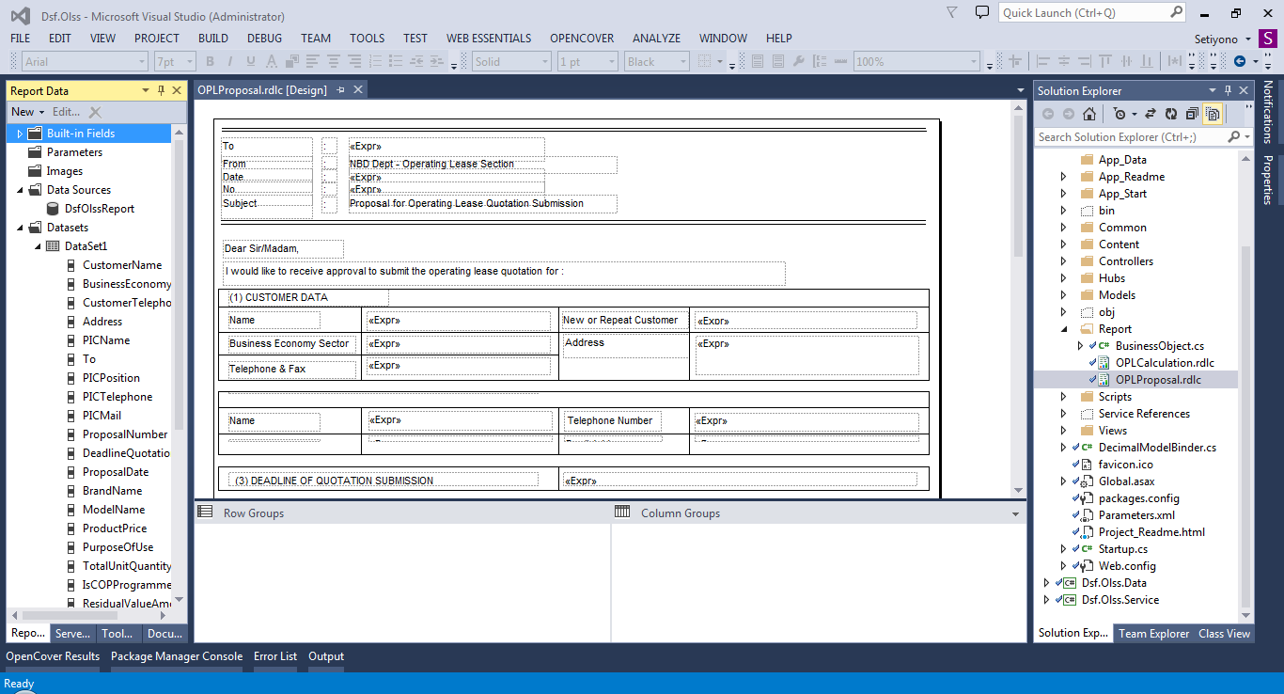
Figure 10. Designing layout report

- Adding Report Viewer to the page
Microsoft.Reporting.WebForms.ReportViewer control will be required to provide RDLC report. And also ScriptManager will be needed to run ReportViewer on same page.
For ease of development, this system will implement WebForm (aspx) for each report (rdlc). Each report layout must related to WebForm.
Now add a WebForm to selected Project.
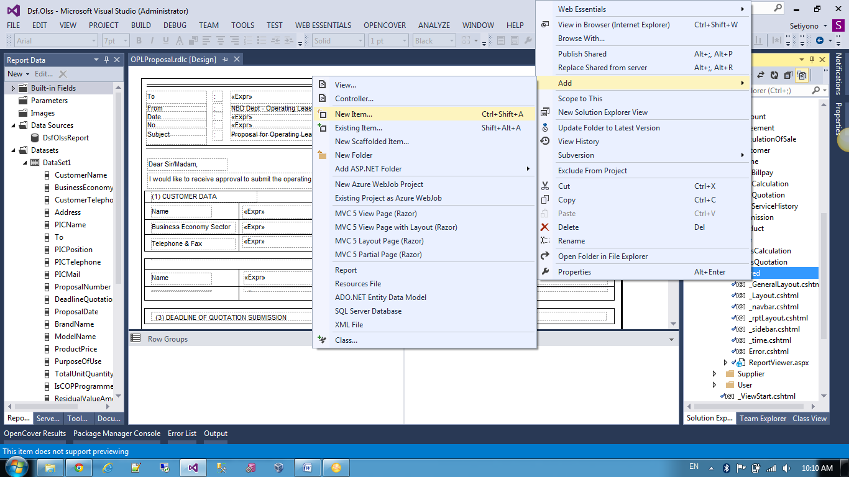
Figure 11. Add New Item

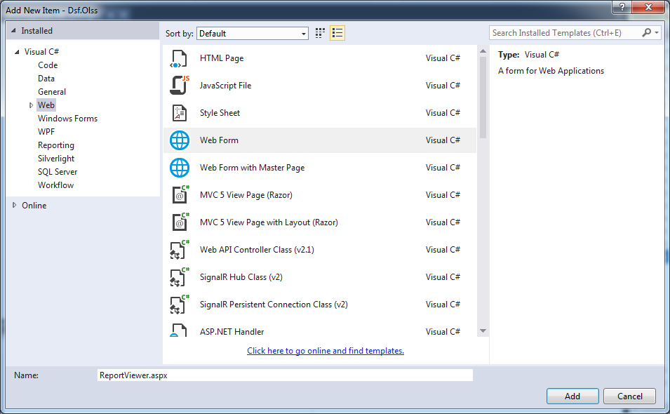
Figure 12. Create new WebForm

Then, add a ScriptManager and ReportViewer control from the Toolbox on a WebForm.
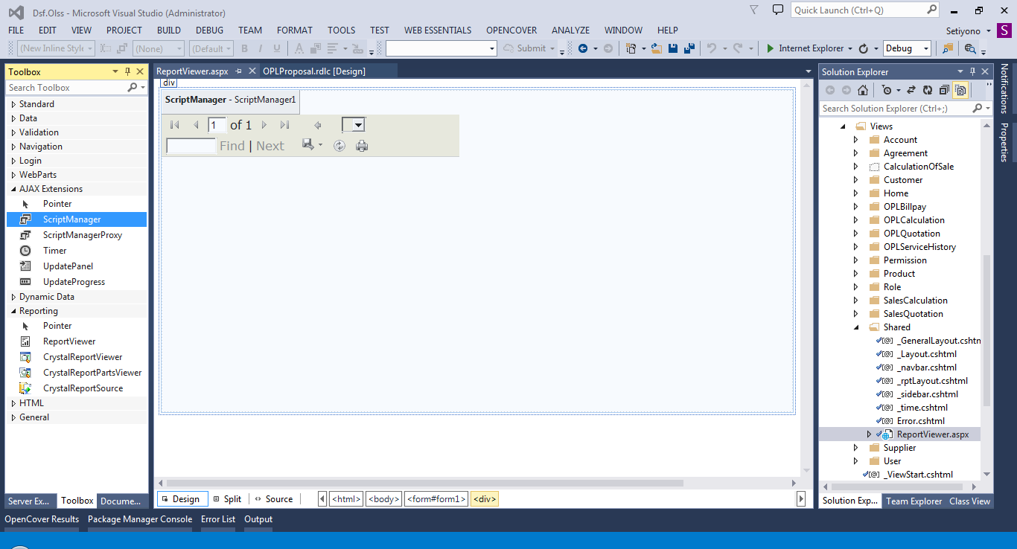
Figure 13. Add ScriptManager and ReportViewer to page

Once add the ReportViewer control to the page, the page must look as below
<%@ Page Language="C#" Inherits="System.Web.Mvc.ViewPage<dynamic>" %>

<%@ Register Assembly="Microsoft.ReportViewer.WebForms, Version=11.0.0.0, Culture=neutral, PublicKeyToken=89845dcd8080cc91" Namespace="Microsoft.Reporting.WebForms" TagPrefix="rsweb" %>

<html xmlns="http://www.w3.org/1999/xhtml">
<head runat="server">
<title></title>
</head>

<body>
<form id="form1" runat="server">
<div>
<asp:ScriptManager ID="ScriptManager1" runat="server"></asp:ScriptManager>
<rsweb:ReportViewer ID="ReportViewer1" runat="server">
</rsweb:ReportViewer>
</div>
</form>
</body>
</html>
Figure 14. WebForm code

- Populating the RDLC Report from Database
Now go to the Source of the ReportViewer.aspx WebForm. Then add the following code for Page_Load event
<%@ Page Language="C#" Inherits="System.Web.Mvc.ViewPage<dynamic>" %>

<%@ Register Assembly="Microsoft.ReportViewer.WebForms, Version=11.0.0.0, Culture=neutral, PublicKeyToken=89845dcd8080cc91" Namespace="Microsoft.Reporting.WebForms" TagPrefix="rsweb" %>

<html xmlns="http://www.w3.org/1999/xhtml">
<head runat="server">
<title></title>
<script runat="server">
void Page_Load(object sender, EventArgs e)
{
if (!IsPostBack)
{
var reportsession = (Dsf.Olss.Common.ReportSessionData)Session["ReportData"];

ReportViewer1.LocalReport.ReportPath = Server.MapPath(reportsession.ReportPath);
ReportViewer1.LocalReport.DataSources.Clear();
ReportDataSource rdc = new ReportDataSource("DataSet1", reportsession.ReportData);
ReportViewer1.LocalReport.DataSources.Add(rdc);
ReportViewer1.LocalReport.Refresh();
}
}

protected void ReportViewer1_PreRender(object sender, EventArgs e)
{
//Excel 2003
VisibleExportFormat((ReportViewer)sender, "Excel", false);
//Excel
VisibleExportFormat((ReportViewer)sender, "EXCELOPENXML", true);
//TIFF file
VisibleExportFormat((ReportViewer)sender, "IMAGE", false);
//PDF
VisibleExportFormat((ReportViewer)sender, "PDF", true);
//Word 2003
VisibleExportFormat((ReportViewer)sender, "WORD", false);
//Word
VisibleExportFormat((ReportViewer)sender, "WORDOPENXML", false);
}

public void VisibleExportFormat(ReportViewer ReportViewerID, string strFormatName, bool isVisible)
{
System.Reflection.FieldInfo info;
foreach (RenderingExtension extension in ReportViewerID.LocalReport.ListRenderingExtensions())
{
if (extension.Name.Trim().ToUpper() == strFormatName.Trim().ToUpper())
{
info = extension.GetType().GetField("m_isVisible", System.Reflection.BindingFlags.Instance | System.Reflection.BindingFlags.NonPublic);
info.SetValue(extension, isVisible);
}
}
}
</script>
</head>

<body>
<form id="form1" runat="server">
<div>
<asp:ScriptManager ID="ScriptManager1" runat="server"></asp:ScriptManager>
<rsweb:ReportViewer ID="ReportViewer1" runat="server"
AsyncRendering="false" SizeToReportContent="true"
Font-Names="Verdana" Font-Size="8pt"
WaitMessageFont-Names="Verdana" WaitMessageFont-Size="14pt"
OnPreRender="ReportViewer1_PreRender">
<LocalReport ReportPath="Report\OPLProposal.rdlc">
</LocalReport>
</rsweb:ReportViewer>
</div>
</form>
</body>
</html>
Figure 15. Code for populating the RDLC report from database

Above is the code to populate the RDLC Report from database. The first statement will get data from Session. The session stores parameters of report. We use single .aspx for viewing all report, so Session store is utilized.

- Insert WebForm into cshtml
Because of We use MVC project, then We need to insert webform into cshtml. We are making use of the partial view. First create a Views with name ProposalReport.cshtml, then replace code with below
@{
ViewBag.Title = "Operating Lease Proposal";
}
@Html.Partial("ReportViewer")
Figure 16. Code for display report on cshtml

Bab 2. Regulation of Using Report

  - Introduction
Required a manual in using report on the OLSS application.
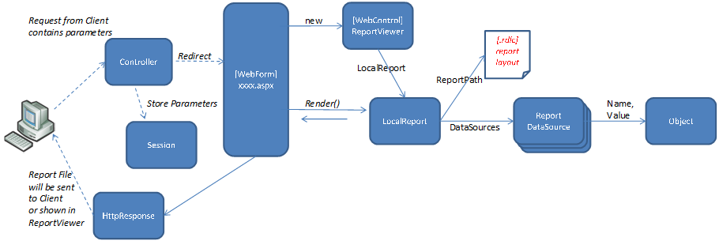
Figure 17. Flow of Using report

  - Prerequisite
Requirements that must be met in order to use the report:
- Modern browser, i.e: Internet Explorer 9 or later
- Pdf viewer, i.e: Adobe Acrobat 6 or later
- Excel viewer, i.e: Ms Excel 2003 or later
- Available printer device
  - Instruction
This section will explain how to use the reporting function (User side) :
- Making request to view the report
This provide an explanation of how to view the report. We will use the Proposal report as an example. Follow these steps :
- Please open OLSS application using a browser.
- Open "Calculation of Operating Lease" screen by click Marketing menu
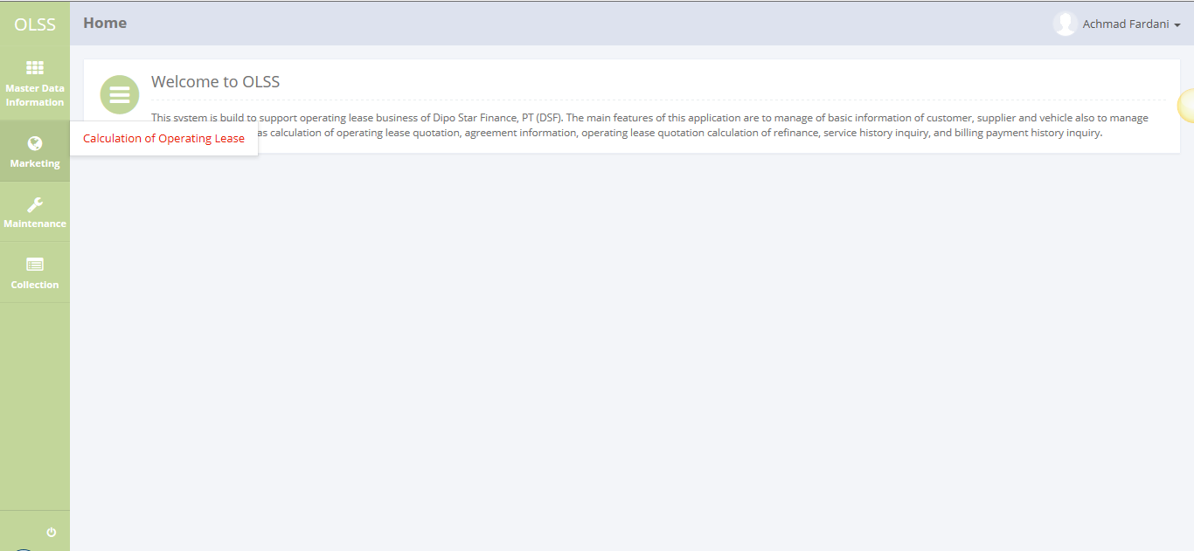
Figure 18. Menu Calculation Operating Lease

- Please select one active record, and click "Proposal Report" button
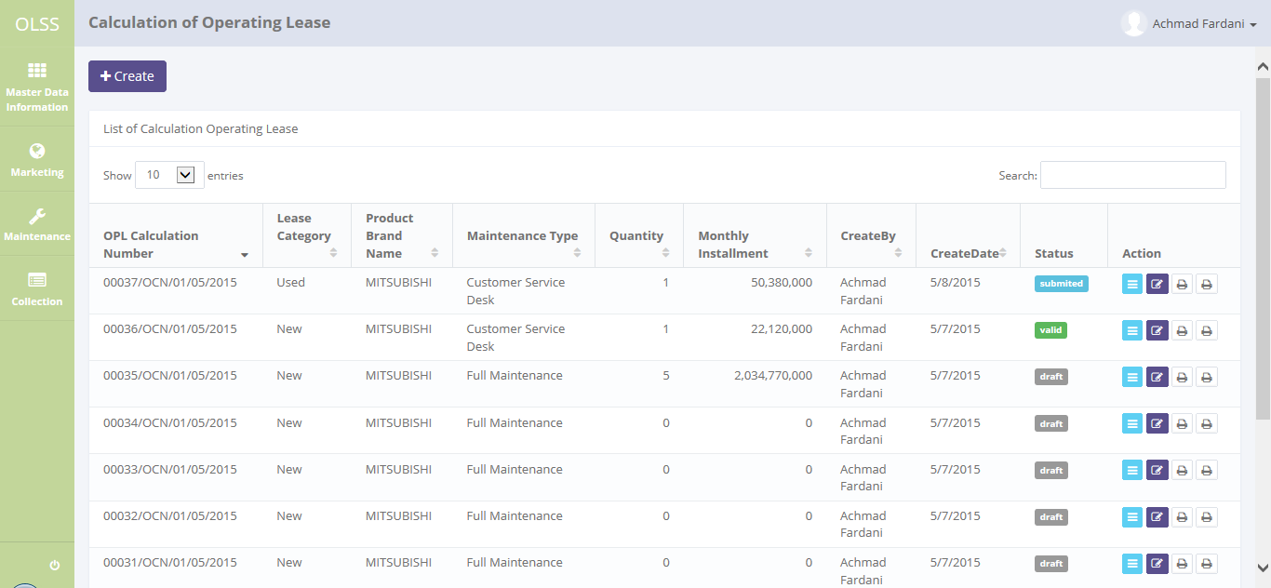
Figure 19. Calculation of Operating Lease screen

- "Proposal Report" screen will be displayed
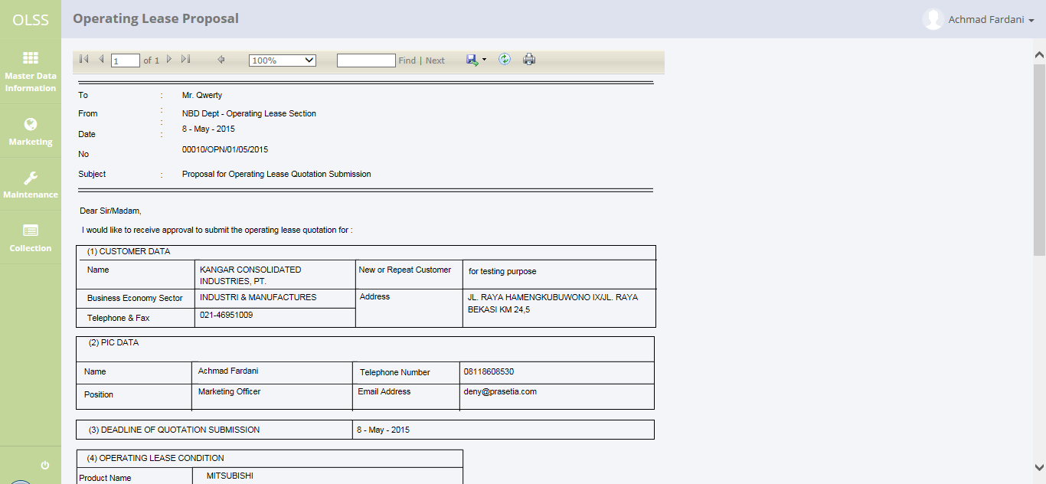
Figure 20. Proposal Report screen

- OLSS application displays the report
This provide an explanation of how to OLSS application give a response to display the report.
- OLSS application receive a request from client (User) contains parameters
- The Request will be processed by a Controller. The Parameters will be stored on Session. The Controller returns View (cshtml) then calls WebForm (aspx)
- The next process, a report will be generated and rendered on the ReportViewer
- User can view the report on "Proposal Report" screen
- Print the report
This provide explanation of how to print the report from ReportViewer.
- On "Proposal Report" screen click "Print" button
Figure 21. Proposal Report screen

- Please select available printer device, then print the report
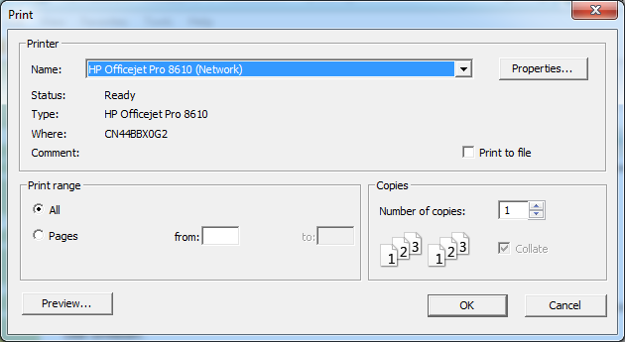
Figure 22. Select available printer device

- Export the report
This provide explanation of how to export the report from ReportViewer. With this function We can save the report in Pdf or Excel format.
- On "Proposal Report" screen click "Save" button
Figure 23. Click Save button

- Please select Pdf option if want to save as Pdf format or select Excel option if want to save as Excel format. Then save the report
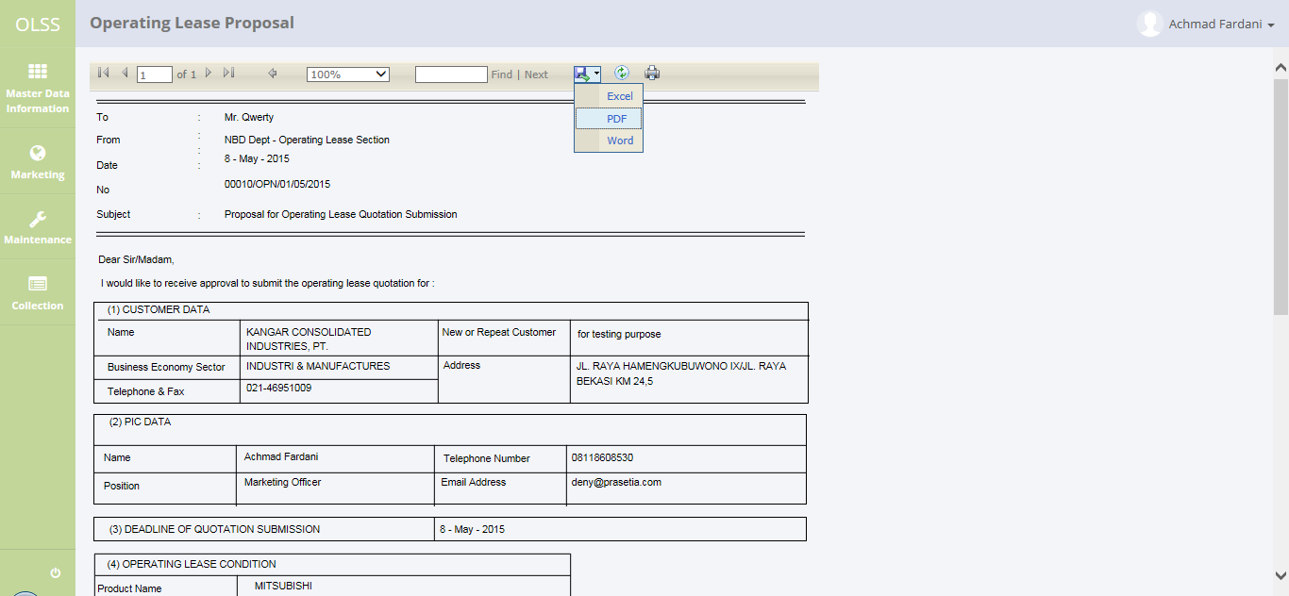
Figure 24. Select available format option

- Open the exported file(Pdf format) with Pdf viewer and make sure the report is correct
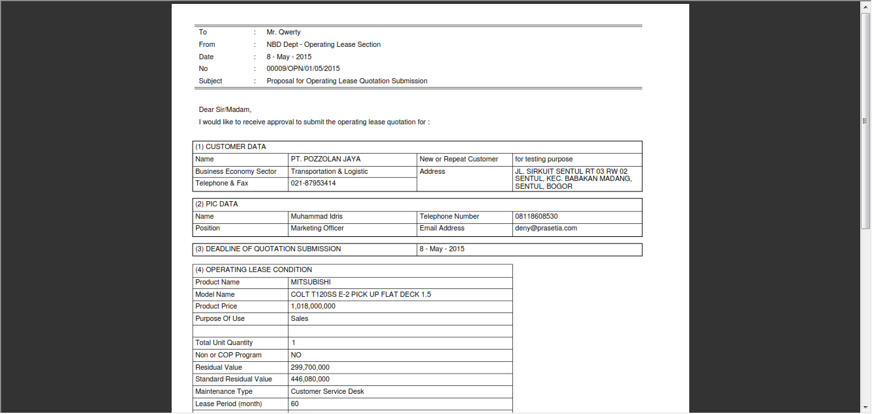
Figure 25. View of report with Pdf viewer

- Open the exported file(Excel format) with Excel viewer and make sure the report is correct
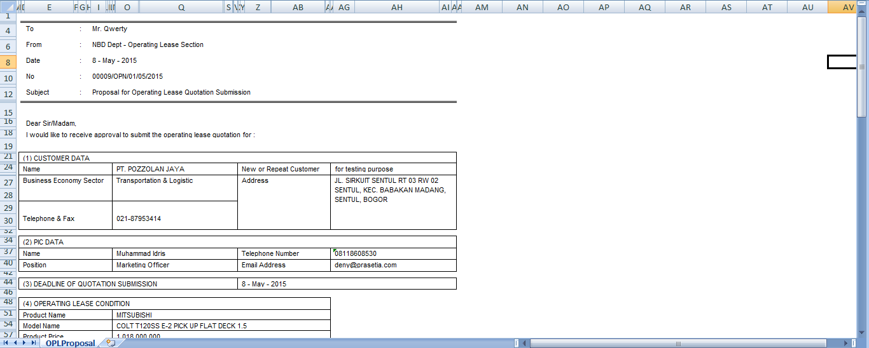
Figure 26. View of report with Excel viewer

